6th eRegions Conference 2016:
Cross-border eSolutions & eServices Prototypes Development
Monday-Tuesday, September 19-20, 2016, Castle Jable, Slovenia
http://eregion.eu/conferences/derc-2016/derc-2016-program

A Framework of Cross-border eCollaboration of Actors in the eRegions: Municipality, Chamber of Commerce, Development Centre, University
Annmarie Gorenc Zoran, PhD & Vera Smodej, MSc
Faculty of Industrial Engineering Novo mesto
Annmarie.Gorenc-Zoran@FINI-UNm.si, Vera.Smodej@siol.net,

Dictionaries define a model more or less as an example to follow or imitate. Synonyms of the word model are prototype, type, blueprint, paradigm, framework and so on. The following piece discusses a positive ongoing experience in the area of cross-border (e)collaboration and considering this experience it is too soon for this to be considered a model that is to be followed or imitated. Nor is it a paradigm as the experiences are not yet ripe for looking or thinking about something in a new way. However, we could argue that our experiences in cross-border (e)collaboration could be considered as a framework that provides a conceptual structure that needs to be built upon, developed, and upgraded to eventually become a model or even a paradigm.
To provide a setting for this framework, following is a background or a short description of cross-border collaboration of actors in two specific regions, that is the municipality, chamber of commerce, development centre, and higher education institutions.
The Faculty of Industrial Engineering Novo mesto was invited to a working visit of the Ambassador of the Republic of Slovenia in Hungary in May 2016. Participants of the working visit included H.E., a representative of the eRegions initiative, and representatives of the Faculty of Industrial Engineering. The purpose of the visit was to start collaboration between both countries, more specifically between both towns – Dunaújváros, Hungary & Novo mesto, Slovenia. At the conclusion of the ambassador’s working visit, bilateral agreements were signed between the University of Dunaújváros and the Faculty of Industrial Engineering with inter-chamber and inter-town agreements between the two countries to be signed in the near future.
However, just signing agreements without any concrete actions is not considered efficient or effective. After signing the mobility agreement, actual mobilities were carried out. However, more importantly, to actually begin cross-border colalborations, the Municipality of Novo mesto, Chamber of Commerce of Dolenjska and Bela krajina, Development Centre, and the Faculty of Industrial Engineering sat down and decided to organize a follow-up visit with key members from Dunaújváros (i.e. with the municipality, chamber of commerce, and university). For cross-border collaborations to begin, we believed that leaders in these areas would increase the likelihood of cross-border collaboration and project realization in profit and not for profit sectors (Figure 1).
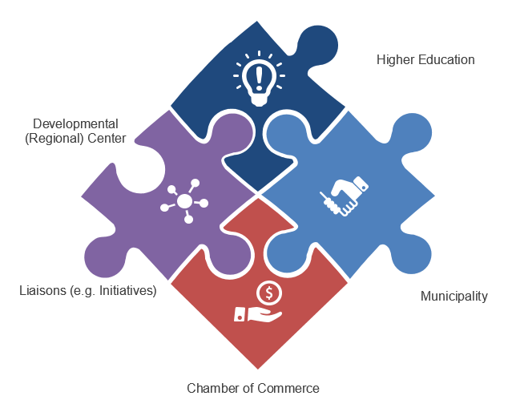
Figure 1. Framework of Actors in eRegions

The purpose of the visit was to identify possible areas of collaboration and within these areas to begin concrete collaborations in the corporate or not for profit sectors. The date was purposefully decided to be aligned with the Danube eRegion Conference – DeRC. Both events were organized where the same delegates were on the panel and also hosted the visit or were invited to Novo mesto. The first two days of the DeRC conference were intense talks on possible cross-border (e)collaborations. On the third day delegates from Dunaújváros serving on the panel would also visit Novo mesto. Members of Dunaújváros accepted the invitation and in September 2016 arrived to Novo mesto. Members of the working visit were Vice-Rector and Director of the Teacher Training Institute at the University of Dunaújváros, and members of the Chamber of Commerce.
On the day of the visit of Dunaújváros delegates to Novo mesto, they were first greeted by the Mayor of the Town Municipality of Novo mesto. He expressed that cross-border, regional and international collaborations are key towards developing developmental projects, receiving European funds, increasing competitiveness, acquiring new knowledge and transference of good practices that consequently have an impact on increasing the quality of life in local areas. He also expressed his interest in concrete collaborations between the two cities. The Vice-Rector at the University of Dunaújváros proposed an idea of cross-collaboration in the area of smart cities. After the mayor’s visit, delegates from Dunaújváros visited the Chamber of Commerce of Dolenjska and Bela krajina and Development (Regional) Center. Delegates were presented with a short overview on projects that these two institutions are working on. The Development (Regional) Center stated that constant effort is placed in encouraging entrepreneurship and regional development and with that also follows the vision, which is to become a key partner in the development of entrepreneurship and regional excellency. Therefore, international cooperation is inevitable. After which, delegates from the Chamber of Commerce from Dunaújváros also presented potential ideas for mutual cross collaboration that were not only concrete ideas, but also feasible ones. The last meeting was with a visit with the consortium members of UNM (i.e., Faculty of Industrial Engineering Novo mesto, Faculty of Information Studies Novo mesto, Faculty of Organisational Studies in Novo mesto, Landscape Governance College). Consortium members presented their respective institutions, projects, and opportunities for international collaboration. The University of Dunaújváros also presented mutual areas of future cooperation. Other delegates from Dunaújváros also received information on possibilities for student and research collaboration. A summary of the afore-mentioned events is depicted in Figure 2 as a framework of milestones.
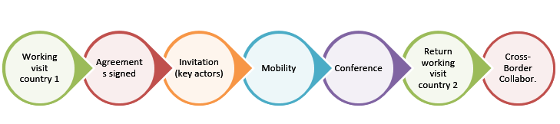 Figure 2. Framework of Milestones

In summarizing our experience and based on feedback from delegates abroad, we could state that networking, communication, willingness for cross-border cooperation, a vision of the benefits of cross-border (e)collaboration, and experience in cross-border collaboration is vital in the sense that meeting individuals on a face-to-face basis, being trustworthy, seeing the potential benefits and responsiveness are key to a successful collaboration. In addition, it is important to have a ‘can-do’ attitude, meaning that concrete steps are defined for the near future, being committed to realization of projects as well as defining key milestones (see Figure 3).
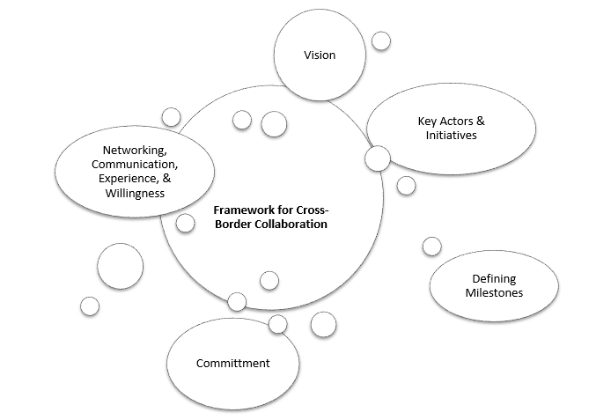
Figure 3. Framework of variables for cross-border collaboration
However, there are other variables that need to be taken into account and may not be visible (i.e. white bubbles in Figure 3), which may include personal characteristics of individuals, leaders in organizations not seeing the long-term benefits, wanting immediate results when international cooperation needs time to build on trustworthiness, and so forth).
To conclude, the experience of Cross-border eCollaboration of Actors in the eRegions: Municipality, Chamber of Commerce, Development Centre, University was a successful one, however, it has not concluded and such a collaboration has only just begun.

